16.8: a), b), c) Using Eq. 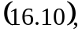

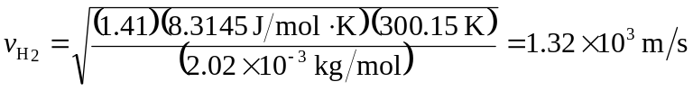
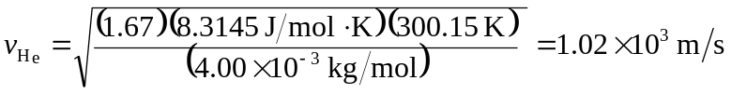
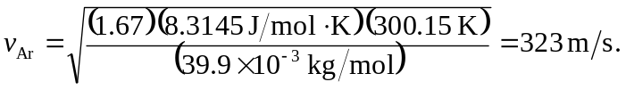

d) Repeating the calculation of Example 16.5 at 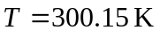 gives 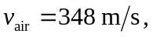 and so 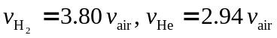 and 